**DIY Soldering Station**

|  |  |
| --- | --- |
| Author | Robbe Theunissen |

Content

1 Introduction 1

2 Material and methods 2

2.1 Materials and Software [1] 2

2.2 Bill of Materials [1] 3

2.3 Methods 4

2.4 Schematic Representation 4

3 Results [1] 5

3.1 PCB Design 6

3.1.1 Electrical Schematics 6

3.1.2 PCB 9

3.2 Mechanical Design 10

3.2.1 Fusion 360 Model 10

4 Discussion 10

5 Reference list 10

# Introduction

This application note describes the design- and assembly process of the DIY Soldering Station. The focus of this project mainly lies on PCB- and product design. Both through-hole and SMD technology is used to mount the components on the PCB.

The soldering station is a fully capable driver where a multitude of different soldering irons are supported. These are the Weller RT, Hakko FX-8801 and the JBC T245.

The Elektor Magazine 665 is used as a guideline throughout the PCB design process as well as component selection.

First the materials and methods will be discussed, then there is a full project overview followed by a discussion about the results. At the end of this document a reference list can be found.

# Material and methods

## Materials and Software [1]

Altium Designer is a software suite that aides in the PCB design process. Both the electrical schematics and the PCB layout were designed with this software. The entire case was designed using a 3D CAD/CAM designer called Fusion 360. The software allows users to create 3D shapes and bodies from scratch. By importing the 3D PCB model created in Altium a sleek and compact design can be achieved.

To drive the electronics an ATmega-4809 from Microchip Technology is used. This is a standalone AVR-microcontroller, the chip is commonly needed in embedded systems. The microcontroller features on-chip flash memory dedicated for program storage.

The chip is part of the Arduino IDE family, the same kind of microcontrollers are implemented on the Arduino development boards. Due to a large userbase, support is quite easy to come by. These kinds of microcontrollers use a programming language similar to C. The open-source software controlling the electronics, written in C++, is structured for easy customization.

To drive the four digits, seven segment LED display a TM1637 LED display driver chip is utilized. This chip is in combination with the AT-mega 4809 microcontroller able to display the current- and requested temperature of the soldering iron.

In order to supply the required voltages to the PCB a stepdown power supply is needed. The transformer supplies the board with 2 x 12 V, 60 VA. The AC volage being output by the transformer is converted to DC. In order to drive the electronics, the voltage gets regulated to 5V, powering both chips. Thanks to the design’s flexibility, both 24V and 12V soldering irons are supported. To protect the electronics from a short circuit a combination of fuses and diodes are used.

The temperature measuring circuit is able to utilize both type-K and type-C DS18B20 1-Wire sensors due to the dual opamp (operational amplifier) configuration. As the name suggest, the opamps amplify the signals received from the temperature probe to get an accurate measurement. By amplifying the signals, jitter caused by the transformer can also be oppressed.

To make the soldering station user friendly an auto-detection mechanism was implemented. The ATmega-4809 will read the value from the sensor every two seconds.

Being able to set the correct soldering temperature is particularly important. An encoder with pushbutton allows the user to interact with the soldering station. The microcontroller measures the temperature at the tip of the iron every 50ms. When a temperature of over 650°C is detected, the display will show an error code informing the user of a malfunction. This is to prevent overheating and causing damage to the soldering iron.

## Bill of Materials [1]

|  |  |  |  |  |
| --- | --- | --- | --- | --- |
| Name | Quantity | Price (€) | Supplier | Delivery date |
| GBU606-G | 2 | 2,54 | Mouser | March 25th |
| 50PK4700MEFC18X40 - 4700uF | 1 | 3,13 | Mouser | March 25th |
| RGA101M1HBK-0811G - 100uF | 2 | 0,32 | Mouser | March 25th |
| 860020672010 - 10uF | 3 | 0,27 | Mouser | March 25th |
| 100nF | 6 | \ | Provided by PXL | \ |
| 10nF | 7 | \ | Provided by PXL | \ |
| FM4007W-W | 1 | 0,14 | Mouser | March 25th |
| MMSZ4689T1G | 1 | 0,18 | Mouser | March 25th |
| SMMDL914T1G | 1 | 0,36 | Mouser | March 25th |
| PEC11R-4225F-S0024 | 1 | 1,53 | Mouser | March 25th |
| TL780-05CKTTR | 1 | 1,80 | Mouser | March 25th |
| TM1637 | 1 | 0,31 | AliExpress | April 1st |
| MCP6002-E_P dual opamp | 1 | 0,48 | Mouser | March 25th |
| ATMEGA4809-PF | 1 | 2,85 | Mouser | March 25th |
| Screw connector | 4 | 2,09 | Mouser | March 25th |
| 1x3header | 3 | \ | \ | \ |
| 1x2header | 1 | \ | \ | \ |
| 1x4header | 1 | \ | \ | \ |
| 1x5header | 1 | \ | \ | \ |
| 2x3header | 1 | \ | \ | \ |
| Inductor VLS6045EX-100M-H | 1 | 0,56 | Mouser | March 25th |
| Transformer CM2545X171B-10 | 1 | 1,52 | Mouser | March 25th |
| KW4-804CVB | 1 | 1,86 | TME |  |
| IRF9Z34NPBF | 1 | 0,91 | Mouser | March 25th |
| 18k | 3 | \ | Provided by PXL | \ |
| 10k | 6 | \ | Provided by PXL | \ |
| 1M | 1 | \ | Provided by PXL | \ |
| 68k | 1 | \ | Provided by PXL | \ |
| 5k6 | 4 | \ | Provided by PXL | \ |
| 100ohm | 3 | \ | Provided by PXL | \ |
| 10M | 1 | \ | Provided by PXL | \ |
| 4k7 | 6 | \ | Provided by PXL | \ |
| RT424005 | 1 | 4,20 | Mouser | March 25th |
| BC547 | 3 | 1,04 | Mouser | March 25th |
| BC557 | 1 | 0,03 | Reichelt | March 28th |
| Power cord 230V with C13 plug | 1 | 3,25 | Bits and Parts | March 25th |
| TST 60/011 INDEL | 1 | 21,91 | TME | March 25th |
| POWER INLET FLANGE MOUNT | 1 | 10,99 | Conrad | March 28th |
| **Price (EST):** |  | 73,25 |

## Methods

During the component selection process, all the components were cross-referenced with their corresponding datasheets.

Due to a shortage in electrical components from the suppliers some components were replaced with a similar one. This while still matching the original specifications.

In order to use the correct tolerances during the case design the book called ‘Tabellenboek voor metaaltechniek’ from Plantyn was used.

## Schematic Representation

Figure 1 represents a detailed flowchart displaying the various stages of the project.

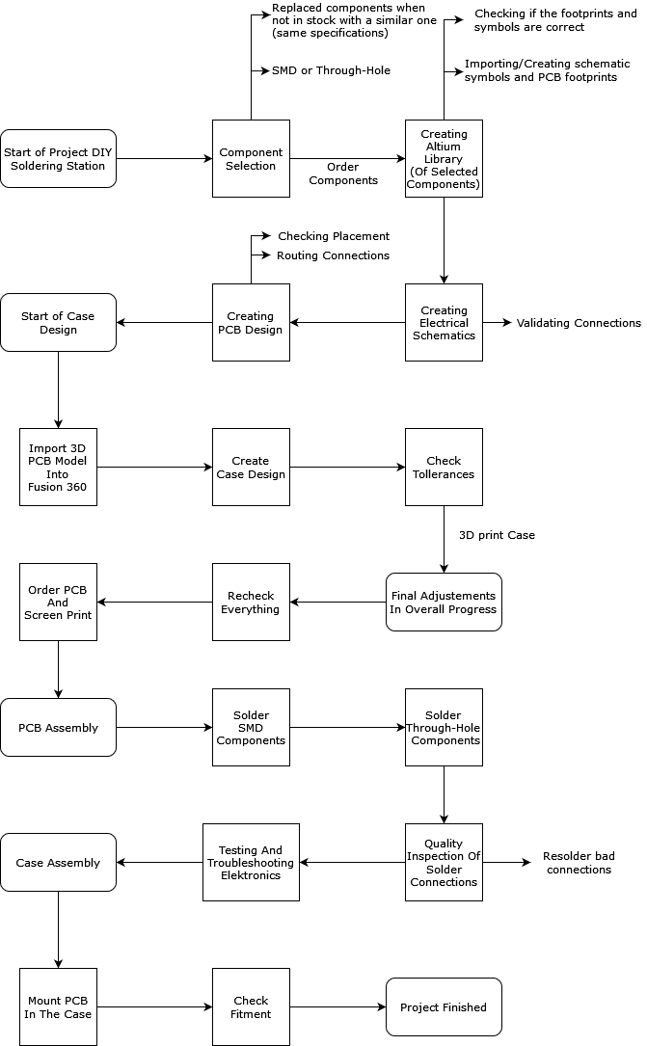

Fig. 1 - Schematic representation of project

# Results [1]

Whilst simplistic in design, the soldering station provides a multitude of advanced features to its users.

When first powering on the device the user is prompted with an options menu. In this menu the user can choose between two options. These options control the voltage provided to the soldering iron’s heating coil and temperature probe located in the tip. The different voltages allow users to use a multitude of different soldering irons from reputable brands such as Weller, Hakko and JBC. After exiting the setup menu, the user can select the desired soldering temperature using the rotary encoder.

In order to troubleshoot a malfunction regarding the soldering iron, an error reporting system is implemented. When a problem is detected, the display will show an error message informing the user of the malfunction. These error-codes can be referenced in the Elektor Magazine.

A replaceable fuse both protects the user and its environment by interrupting the power to the device when a short circuit or overvoltage occurs. As an extra safety feature the PCB is coated in a clear epoxy. This coat acts as an isolator, protecting the exposed contacts from accidental short circuits. The voltage transformer that converts the 230V AC to 2 x 12V AC is fully enclosed in the case. This placement is one of the key features to a safe design.

The case is based on a computer test bench design. The open design shows the inner workings of the soldering station while still being functional. Threaded insert, melted in the plastic, secure the PCB to the case. The compact design of the case allows for portability and easy carry. Both durable and eco-friendly materials are used to 3D-print the case.

Component selection and placement is the key to a compact PCB. A combination of SMD and through-hole technology is used to achieve this. Using SMD’s adds a few extra steps to the assembly process of the PCB.

The electrical schematics are complete and without any faults. A lot of research, time and dedication went into optimizing the electrical schematics as well as the PCB itself. Multiple versions and ideas were boiled down to one final design.

## PCB Design

### Electrical Schematics

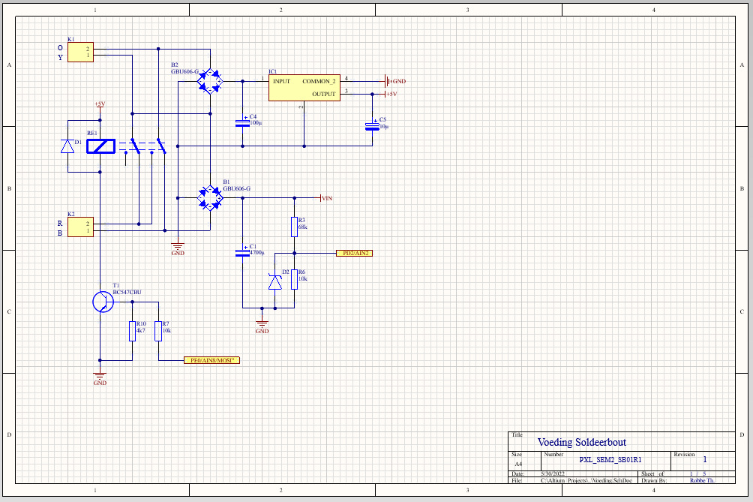

Fig. 2 – Electrical schematic of the power supply unit

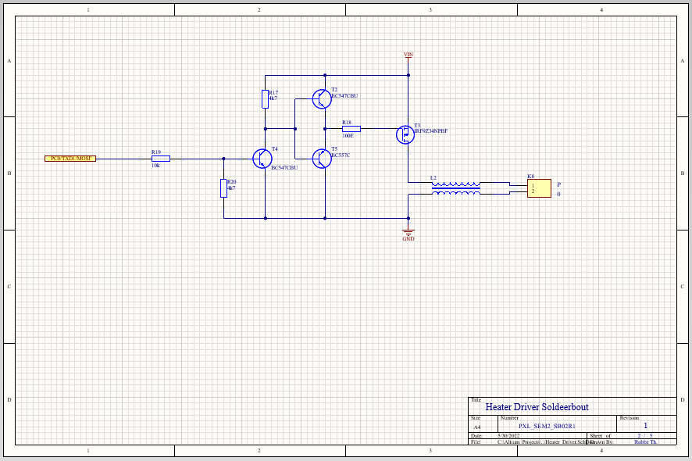

Fig. 3 - Electrical schematic of the heater driver unit

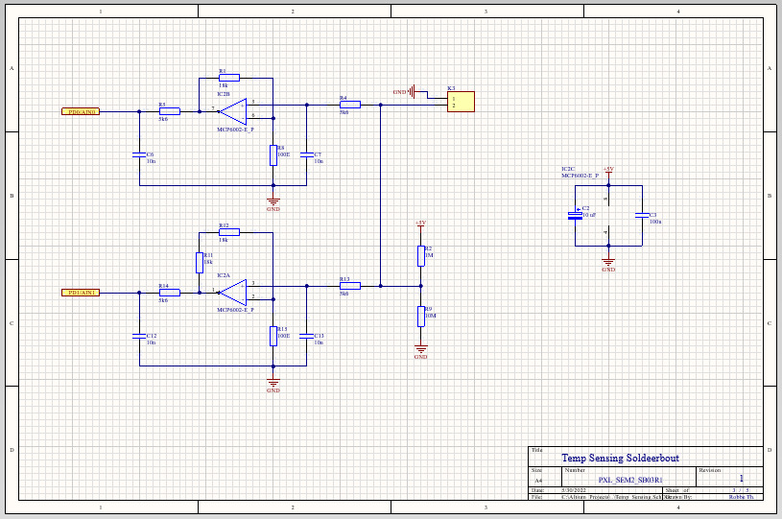

Fig.4 - Electrical schematic of the temperature sensing unit

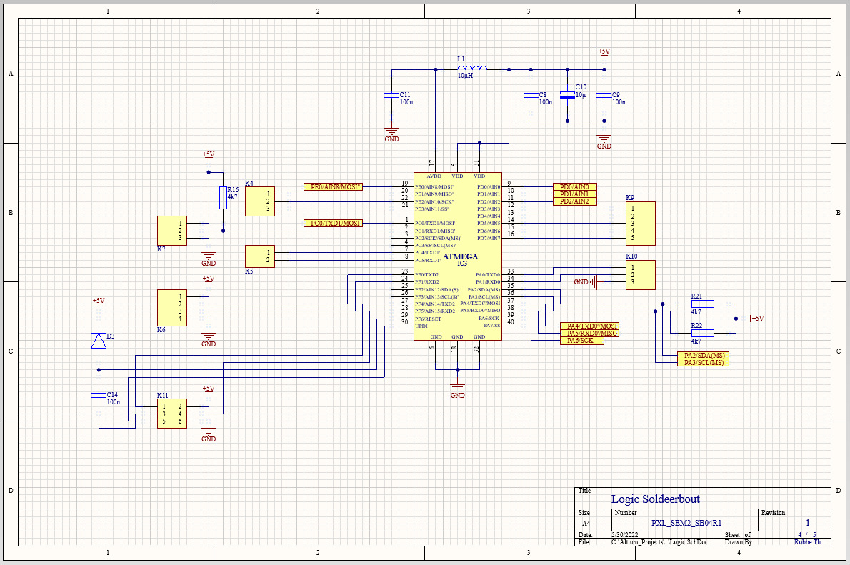

Fig.5 - Electrical schematic of the logic unit

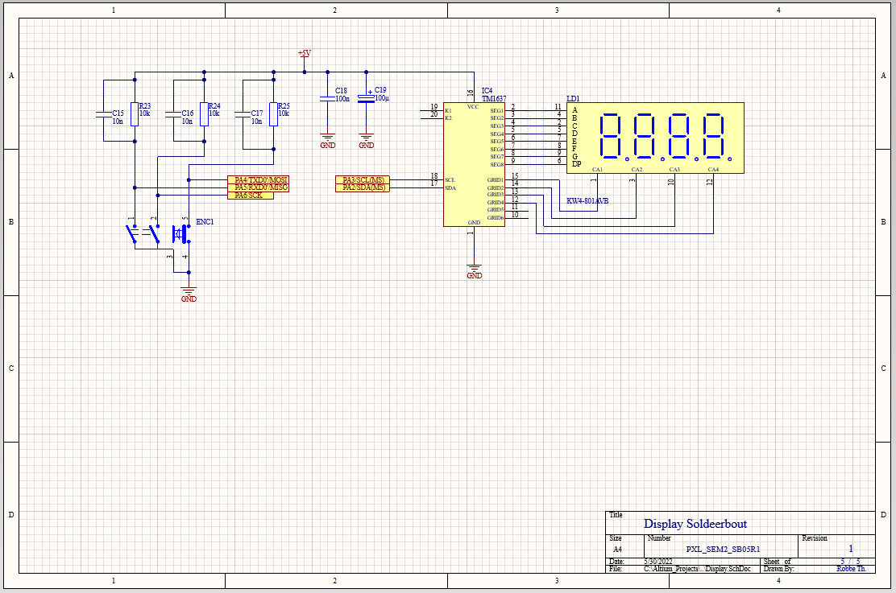

Fig. 6 - Electrical schematic of the display unit

### PCB

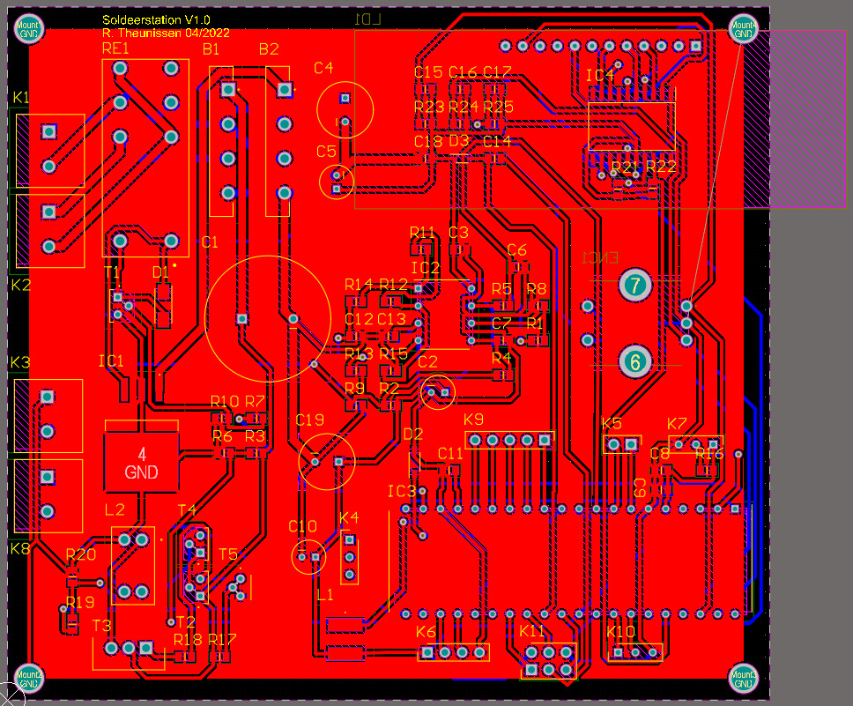

Fig. 7 – 2D PCB layout

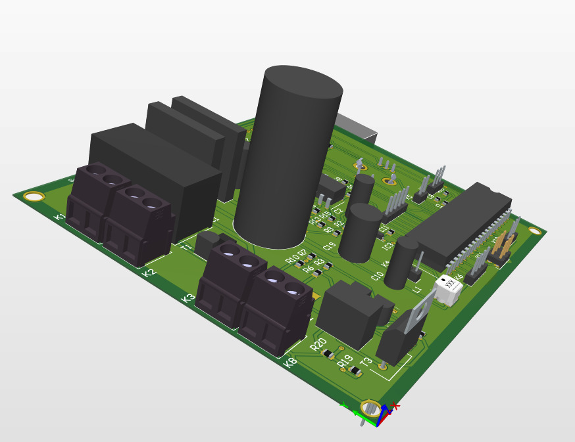

Fig. 8 – 3D PCB layout

## Mechanical Design

### Fusion 360 Model

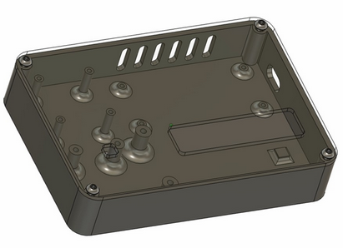

Fig. 9 – Fusion 360 3D case design

# Discussion

During the PCB design process a few problems were encountered.

Due to the scarcity of certain electronical components, namely the DC-DC converter (used in the original electrical schematic provided by Elektor) was replaced by a DC regulator with the same specifications. There are a few drawbacks by using this component: An increase in power consumption, thus making it less efficient and producing a lot more heat. To keep the PCB’s temperature at an acceptable level a skeletonized case ended up being designed.

To protect the PCB from accidental short circuits a clear coating was sprayed on both the front- and backside. This coating acts like an insulator preventing the exposed contacts from being touched. A negative effect is the thermal insulation retaining some of the generated heat, thus the skeletonized case.

Almost all of the provided schematic symbols needed a re-design in order for them to comply to the EU schematic standards.

Not all of the component’s footprints matched up with the physical dimensions of their contact areas. All of the footprints needed to be checked in order to use them during the PCB design phase of the project.

To keep the PCB as compact as possible mainly SMD components were used. The challenge of using SMD components is its small size. The soldering paste was applied with a custom-made stencil provided by the PCB manufacturer. In order to correctly place these tiny components a microscope was used.

This project allowed me to create a better understanding of the steps that need to be taken in order to make a working product. I took both the case- and PCB design as a challenge, in which I succeeded.

# Reference list

[1] “Elektor Magazine,” *DHZ Soldeerstation: nieuw ontwerp voor de Weller RT en andere soldeerbouten,* vol. 61, no. 665, May, June 2021. [Online]. Available: [Elektor Magazine 665](https://www.elektormagazine.nl/magazine/elektor-177/59601). [Accessed April 15, 2022].